

FOURTH YEAR PROJECT PROPOSAL

NAME: WAWERU DICKSON MWANGI
REGNO: CT203/109339/22
COURSE: BIT
YEAR: YEAR 4 SEMISTER 2
TITLE: Decentralized Academic Credential Verification

DECLARATION
I, Waweru Dickson Mwangi, hereby declare that the project titled “A Blockchain-Based System for Decentralized Academic Credential Verification submitted in partial fulfillment of the requirements for the degree of Bachelor of Information Technology at Meru University, is my original work.
This project has been carried out under the supervision of Dr MWENDA GICHURU, INFORMATION TECHNOLOGY DEPARTMENT
I certify that:
The work contained in this project is genuine and has been completed by me.
No part of this work has been submitted elsewhere for any other degree or qualification.
All sources of information and literature have been duly acknowledged in the references.
Wherever required, I have obtained the necessary permissions for the use of software, data, and other materials.
I understand the implications of any violation of academic integrity.

Signature of Student: ________________________
Name: WAWERU DICKSON MWANGI
REGNO: CT203/109339/22
Date: 20/1/2026

Certified by:

Signature of Supervisor: ______________________
Name: MWENDA GICHURU
Date:

DEDICATION

ACKNOWLEDGEMENT

I sincerely thank my supervisor, Dr. /Prof MWENDA GICHURU, for their guidance and support throughout this project.
My gratitude extends to the Department Of Information Technology at Meru University Of Science And Technology for providing the necessary resources.
I am also grateful to my colleagues and friends for their valuable discussions and encouragement.
Lastly, I thank my family for their unwavering love and support, without which this work would not have been possible.

Dickson Mwangi Waweru

TABLE OF CONTENT
Contents
0
0
DECLARATION 1
DEDICATION 2
ACKNOWLEDGEMENT 3
TABLE OF CONTENT 4
CHAPTER ONE: INTRODUCTION 7
1.1 Background of the Study 7
1.2 Problem Statement 8
1.3 Research Objectives 9
1.4 Research Questions 10
1.5 Significance of the Study 10
1.6 Scope of the Study 11
CHAPTER TWO 11
LITERATURE REVIEW 12
2.0 Overview 12
2.1 Functions of Existing Academic Credential Systems 12
2.2 Components of Existing Credential Systems 12
2.3 Characteristics and Features of Existing Systems 12
2.4 Types of Existing Systems 13
2.5 Challenges of Existing Systems 13
2.6 Related Studies and Work 13
2.7 Summary 13
CHAPTER THREE 14
METHODOLOGY 14
3.0 Overview 15
3.1 Research Design 15
3.2 Population and Sampling 15
3.3 Data Collection Methods 15
3.4 Development Tools and Materials 16
3.5 System Development Methodology 16
3.6 System Design 16
3.7 Data Processing and Analysis 16
3.8 Ethical Considerations 17
CHAPTER FOUR 17
SYSTEM ANALYSIS 17
4.0 Overview 17
4.1 Feasibility Study 18
4.1.1 Technical Feasibility 18
4.1.2 Economic Feasibility 18
4.1.3 Operational Feasibility 18
4.1.4 Legal Feasibility 18
4.1.5 Schedule Feasibility 18
4.2 Description of Current System 20
4.2.1 Functional Components of the Current System 20
4.2.2 Weaknesses of the Current System 20
4.3 Summary of System Analysis 21
CHAPTER FIVE 22
SYSTEM DESIGN 22
5.0 Overview 22
5.1 Description of the Proposed System 22
5.2 Functional Requirements of the Proposed System 23
5.2.1 User Authentication and Access Control 23
5.2.2 Institution Functions 23
5.2.3 Student Functions 23
5.2.4 Employer and Verifier Functions 23
5.2.5 Administrative Functions 24
5.2.6 Interface Requirements 24
5.2.7 Business Requirements 24
5.2.8 Regulatory and Compliance Requirements 24
5.2.9 Security Requirements 24
5.3 Non-Functional Requirements of the Proposed System 25
5.3.1 Performance Requirements 25
5.3.2 Security Requirements 25
5.3.3 Usability Requirements 25
5.3.4 Reliability Requirements 25
5.3.5 Scalability Requirements 25
5.3.6 Maintainability Requirements 25
5.3.7 Availability Requirements 25
5.3.8 Data Integrity Requirements 25
5.3.9 Interoperability Requirements 26
5.4 Logical Design of Proposed System 26
5.5 Physical Design of Proposed System 28
5.5.1 Input Design 28
5.5.2 Output Design 29
5.5.5 Hardware and Software Requirements 29
CHAPTER SIX 30
SYSTEM IMPLEMENTATION 30
6.0 Overview 30
6.1 System Testing 30
6.2 System Changeover / Installation 33
6.3 Documentation 34
CHAPTER SEVEN 35
CONCLUSION AND RECOMMENDATION 35
7.0 Achievements 35
7.1 Challenges 35
7.2 Proposed System Limitations 35
7.3 Recommendation / Future Work 35
7.4 Conclusion 35
APPENDICES 36
APPENDIX A: FEASIBILITY STUDY REPORT 36
APPENDIX B: USER / OPERATION MANUAL 37
APPENDIX C: TEST CASES AND RESULTS 38
APPENDIX D: ADDITIONAL SCREENSHOTS 38
APPENDIX E: SUPPORTING DIAGRAMS 38
REFERENCES 39

CHAPTER ONE: INTRODUCTION

1.1 Background of the Study
Academic credentials, such as degrees, certificates, and transcripts, are essential for employment, higher education, and professional advancement. These credentials provide proof of competence and are used by employers and institutions to evaluate qualifications and make informed decisions. However, in Kenya and globally, the prevalence of fake academic certificates poses a major challenge. Employers and institutions often struggle to verify the authenticity of credentials using slow, manual, and centralized systems. These conventional systems lack transparency, are prone to data manipulation or loss, and often involve high administrative costs and delays (Onyango, 2020).
Recent technological advancements, particularly in blockchain technology, provide potential solutions to these challenges. Blockchain is a decentralized, immutable, and transparent ledger that allows information to be securely stored and verified without reliance on a central authority (Nakamoto, 2008). Non-Fungible Tokens (NFTs) provide a method to uniquely represent digital assets, making it possible to create secure, verifiable digital versions of academic credentials. By issuing academic records as NFTs on a blockchain, each credential becomes tamper-proof, easily verifiable, and globally accessible.
Implementing a blockchain-based academic credential system empowers learners with ownership of their records, reduces administrative burden for educational institutions, and provides employers with instant verification mechanisms. This approach also addresses challenges such as credential fraud, inefficiency in verification processes, and the limited portability of traditional paper-based credentials. In addition, it supports vulnerable populations, including refugees and migrants, who may lack access to physical educational documents (Grech & Camilleri, 2017).
The study seeks to explore and develop a decentralized academic credential management and verification system that leverages blockchain and NFTs to improve the security, transparency, and accessibility of academic records

1.2 Problem Statement
The ideal situation in academic credential management is a system in which credentials can be verified instantly, securely, and globally, while learners maintain ownership of their records. Currently, most educational institutions rely on centralized, paper-based, or legacy digital systems that are slow, vulnerable to forgery, and costly to maintain. These systems often require manual verification, which can take days or weeks, creating inefficiencies for both employers and institutions. Furthermore, the lack of transparency makes it difficult to detect fraudulent certificates, undermining trust in education systems and professional qualifications.
In Kenya, as elsewhere, the consequences of relying on such systems are significant. Fake or manipulated academic certificates compromise recruitment processes, increase administrative costs, and expose learners to potential disputes over record ownership. Traditional systems also fail to support lifelong learning records, aggregating credentials from multiple institutions and online platforms, which limits the portability of learners’ achievements.
Therefore, there is a need for a decentralized, trustless system that ensures the authenticity, portability, and accessibility of academic credentials while reducing administrative costs and streamlining verification processes. The proposed blockchain and NFT-based system aims to provide a solution that addresses these challenges, giving learners lifelong ownership of their records and making credential forgery virtually impossible.

1.3 Research Objectives
General Objective
to develop a decentralized academic credential management, verification system using blockchain.
Specific Objectives
1. To Design a system that issues tamper-proof academic credentials using blockchain technology.
2. To enable learners to own and manage their academic credentials through digital wallets.
3. To facilitate instant verification of academic credentials by employers and educational institutions.
4 To ensure interoperability of the system with existing educational and professional standards.
5. To automate administrative processes, including credential issuance through smart contracts.
6. To provide secure access to academic records for learners across different geographical locations.
7. To Explore token-based mechanisms to incentivize educational content creation activities within the platform.

1.4 Research Questions
The study will seek to answer the following research questions:
- How can blockchain technology be used to issue tamper-proof academic credentials?
- In what ways can learners maintain ownership, control of their academic records using digital wallets?
- How can instant verification of credentials be facilitated for employers, educational institutions?
- How can the system ensure interoperability with existing standards across institutions, countries?
- How can administrative processes, such as issuance?
- How can secure access to academic records be provided for learners in different geographical locations?
- What token-based mechanisms can be implemented to incentivize participation within the system?

1.5 Significance of the Study
The proposed system has multiple benefits for learners, institutions, and employers. Learners will gain lifelong ownership of their verified credentials, ensuring authenticity and easy accessibility from anywhere in the world. Educational institutions will benefit from reduced administrative workload, lower verification costs, and enhanced trust in their credentialing processes. Employers will have access to an instant and reliable method to verify credentials, reducing hiring risks and ensuring compliance with industry standards.
At a broader level, the system contributes to the development of a global, learner-centric ecosystem for credential management, fostering trust, transparency, and efficiency in education and professional sectors. The findings of this study may also provide a reference for policymakers, educational technology developers, and researchers interested in blockchain-based educational solutions.

1.6 Scope of the Study
The study focuses on the design, development, and implementation of a decentralized academic credential management and verification system using blockchain and NFTs. The system will target higher education institutions in Kenya, including universities and colleges, and will cover the issuance, storage, and verification of degrees, certificates, and transcripts. The study includes the development of a student portal for managing credentials, an admin dashboard for institutions to issue and monitor credentials, and a verification portal for employers. The research will also explore interoperability with global standards, use of IPFS for decentralized storage, and integration of smart contracts for automated credential processes. The project will be implemented within a six-month period, with measurable results including system functionality, security, and verification efficiency.

CHAPTER TWO

LITERATURE REVIEW

2.0 Overview
A literature review provides a comprehensive analysis of existing knowledge on a given topic, synthesizing findings from prior studies while highlighting theoretical and methodological contributions. For this research, the review focuses on existing systems for academic credential management and verification, the application of blockchain technology in digital record-keeping, the use of non-fungible tokens (NFTs) for secure identity representation, and the challenges associated with traditional and centralized credentialing systems. This review is integrative in nature, examining relevant empirical and theoretical work to identify gaps that justify the need for a decentralized, blockchain-based credential verification system.

2.1 Functions of Existing Academic Credential Systems
Traditional academic credential systems primarily function to issue, store, and verify educational certificates such as diplomas, transcripts, and course completions. Universities and other credential-issuing institutions maintain centralized databases where records are entered, managed, and later accessed for verification purposes. Verification is often performed manually through document authentication, requiring administrative effort from both institutions and prospective employers. In some countries, online portals exist for students to download digital certificates; however, these systems still rely on central servers and may lack cryptographic protection. Studies indicate that while conventional systems perform basic record storage effectively, they are inefficient in ensuring global accessibility, real-time verification, and resistance to tampering.

2.2 Components of Existing Credential Systems
Most existing systems consist of several core components: a centralized database that stores student records, an interface for administrators to manage credentials, and portals for students to access their records. Verification usually occurs through request forms or QR codes linking to the database. However, the lack of decentralization means that records are vulnerable to alteration, loss, or unauthorized access. Integration with identity verification mechanisms, such as government IDs or institutional authentication, is often limited, reducing the overall trustworthiness of the credentials. Scholars argue that these limitations contribute to systemic inefficiencies and hinder cross-institutional or international verification.

2.3 Characteristics and Features of Existing Systems
Existing academic credential systems are generally characterized by centralized control, manual verification processes, and limited portability. While some platforms offer features such as password-protected student portals, automated transcript generation, and basic analytics for administrators, they fall short in providing lifelong ownership of records for learners. These systems often do not support interoperability across institutions, making it challenging for credentials to be recognized globally. The absence of cryptographic proofs in many platforms increases susceptibility to fraud, a concern highlighted in studies examining the rise of fake academic certificates in multiple regions.

2.4 Types of Existing Systems
Academic credential systems vary based on their technological implementation. Paper-based systems remain prevalent in many institutions, especially in developing countries, and rely heavily on manual processes for issuance and verification. Digital centralized systems represent a step forward, enabling students to access records online, yet they still require trust in the institution’s infrastructure. Emerging blockchain-based pilot projects provide a decentralized alternative, offering cryptographic immutability, transparency, and enhanced security. Within this category, NFT-based implementations have begun to appear, uniquely representing each credential to prevent duplication and forgery.

2.5 Challenges of Existing Systems
The literature identifies several challenges inherent in traditional and digital centralized systems. The first major concern is vulnerability to fraud, as paper certificates can be forged and databases can be manipulated. The second challenge is inefficiency, with verification processes often taking days or weeks, imposing administrative costs on institutions and delays for employers. Thirdly, the lack of portability restricts learners’ control over their records, limiting access to their own credentials and creating dependency on issuing institutions. Additionally, interoperability across institutions and international borders remains a persistent issue, resulting in difficulties for learners seeking employment or further education abroad. Studies consistently highlight the need for solutions that enhance security, efficiency, and user autonomy.

2.6 Related Studies and Work
Prior research has explored the potential of blockchain technology for secure record-keeping and verification. Blockchain provides a decentralized, tamper-proof ledger that can be accessed globally, ensuring transparency and resilience against fraud. Non-fungible tokens offer a method to uniquely identify digital assets, including academic credentials, enabling learners to maintain ownership and control over their educational achievements. Several pilot projects, such as MIT’s Digital Diploma initiative and the Holberton School blockchain credentialing platform, demonstrate the feasibility of this approach. Researchers also emphasize the importance of integrating standards such as W3C Verifiable Credentials and Decentralized Identifiers, ensuring interoperability and global recognition. Studies indicate that when blockchain and NFTs are combined with decentralized file storage solutions like IPFS, credential systems can achieve security, accessibility, and longevity far beyond conventional systems.

2.7 Summary
The literature reviewed underscores the limitations of centralized academic credential systems in preventing fraud, ensuring efficiency, and providing learner ownership. Blockchain and NFT technologies emerge as promising solutions, offering immutable, globally verifiable, and learner-controlled credentials. Despite existing pilot implementations, gaps remain in scalability, adoption, and integration with global standards. This research proposes a decentralized academic credential management and verification system that leverages blockchain, NFTs, and IPFS to address these gaps. The proposed system aims to provide a secure, learner-centric, and globally accessible platform, thereby improving trust, reducing administrative burdens, and empowering individuals with lifelong ownership of their academic records.

CHAPTER THREE

METHODOLOGY

3.0 Overview
This research seeks to develop a decentralized academic credential management and verification system using blockchain and NFTs. The system will enable universities to issue, manage, and verify academic credentials digitally, while empowering learners with full ownership of their records. The study bridges the gap identified during the literature review, where traditional credential verification systems are slow, centralized, and vulnerable to fraud. This chapter outlines the approach to be used in conducting the research, focusing on the research design, target population, sampling technique, data collection methods, development tools and materials, system development methodology, system design, data processing and analysis, and ethical considerations.

3.1 Research Design
The study will adopt an experimental research design. An experimental design allows specific cases to be exposed to all levels of the independent variable of interest, facilitating the testing of system functionality and effectiveness. The approach is suitable for developing the decentralized credential system as it enables practical testing of the platform with students, university administrators, and employers. A quantitative approach will also be applied to measure efficiency gains in credential verification, system usability, and the reduction in administrative time and cost. Data will be collected from participants to determine the impact of the system on verification speed, reliability, and user satisfaction.

3.2 Population and Sampling
Population refers to the well-defined collection of individuals or objects with similar characteristics. The target population for this research will include students, university administrators, and employers within Kenya. The sample will be selected using stratified sampling to ensure representation across different user categories. Students will be divided into undergraduate, postgraduate, and continuing education cohorts, ensuring that feedback is representative of the full student body. University administrators will include credential issuing officers and IT staff, while employers will comprise HR personnel from multiple sectors. Stratified sampling ensures that each group contributes proportionately to the study, thereby reducing bias and improving reliability of the findings. Sample sizes will be determined using established statistical formulas to achieve sufficient confidence in the results.

3.3 Data Collection Methods
Data collection will involve a combination of questionnaires, interviews, and system prototyping. Questionnaires will capture quantitative feedback from students and employers regarding credential access, usability, and verification speed. Structured interviews with university administrators will provide qualitative insights into system integration, workflow improvements, and potential operational challenges. System prototyping will allow participants to interact with the decentralized platform, enabling observation of behavior, collection of usability metrics, and validation of system functions. This mixed-method approach ensures comprehensive data to evaluate both technical and user-oriented outcomes.

3.4 Development Tools and Materials
The system will be developed using Ethereum blockchain for smart contract deployment, with NFTs conforming to the ERC-721 standard to uniquely represent credentials. IPFS will serve as the decentralized storage platform for credential files. The front-end interfaces for students, administrators, and employers will be developed using React.js, while the back-end APIs and blockchain interactions will be implemented with Node.js. Development and testing will be conducted on machines with a minimum specification of 16GB RAM, modern multicore processors, and internet connectivity sufficient for blockchain operations and IPFS access.

3.5 System Development Methodology
The system will be developed using the Rapid Application Development (RAD) methodology. RAD allows iterative prototyping and fast feedback incorporation, making it suitable for developing a system with multiple user interfaces and smart contract functionalities. The methodology ensures that each component of the system can be developed, tested, and refined incrementally, reducing the likelihood of errors and improving overall system usability. RAD also supports collaboration with stakeholders during the development phase, ensuring the final system meets user expectations.

3.6 System Design
System design encompasses the architectural and functional layout of the decentralized credential platform. The architecture consists of credential issuance via smart contracts, credential storage on IPFS, student portals for managing and sharing credentials, employer portals for verification, and administrative dashboards for university management. A flowchart will be used to illustrate the processes of credential issuance, storage, retrieval, and verification, demonstrating the interaction between different system components. The design ensures clarity in the workflow, facilitates integration of blockchain and NFT functionalities, and supports scalability for future system expansion.

3.7 Data Processing and Analysis
Data processing involves organizing raw data into meaningful formats. Collected questionnaires and interview responses will undergo editing to remove errors, coding to categorize responses, classification to group data by participant type, and tabulation to summarize key metrics. Data analysis will employ descriptive statistics such as mean, median, standard deviation, and frequency distributions to present insights on system performance and usability. Inferential statistics, including correlation analysis, will assess relationships between system usage patterns and verification efficiency. For example, frequency distributions will indicate the number of credentials verified per day, while standard deviation will measure variations in verification times across different users. Data analysis will provide evidence of system effectiveness and support conclusions on the potential impact of the decentralized credential system.

3.8 Ethical Considerations
Ethical standards will guide the research to ensure integrity, transparency, and respect for participants. Consent will be obtained from all participants prior to data collection. Data will be anonymized to protect privacy, and all system interactions during prototyping will follow confidentiality protocols. Ethical conduct will also prevent fabrication or manipulation of data, promoting accuracy and credibility in reporting findings. Compliance with ethical guidelines ensures that the study not only advances knowledge but also respects the rights and dignity of all participants.

CHAPTER FOUR

SYSTEM ANALYSIS

4.0 Overview
This chapter presents the system analysis for the proposed Decentralized Academic Credentials Verification system. It examines the feasibility of developing and implementing the system, describes the current system used in academic credential issuance and verification, and highlights the weaknesses that justify the need for the proposed solution.

4.1 Feasibility Study
A feasibility study is an evaluation carried out to determine whether a proposed system is practical and suitable for implementation within a given environment. For the Decentralized Academic Credentials Verification system, the study focused on technical, economic, operational, legal, and schedule feasibility.

4.1.1 Technical Feasibility
The system is technically feasible because it can be developed using available web technologies, backend services, databases, and decentralized verification tools. Users can access the platform using internet-enabled computers and smartphones.

4.1.2 Economic Feasibility
The system is economically feasible because open-source technologies reduce development cost while the platform is expected to reduce verification delays, paperwork, and fraud-related losses.

4.1.3 Operational Feasibility
The system is operationally feasible because it addresses real needs of institutions, students, employers, and administrators. User training will still be important for successful adoption.

4.1.4 Legal Feasibility
The system is legally feasible provided access control, privacy, and institutional data governance requirements are observed during deployment and use.

4.1.5 Schedule Feasibility
The project is schedule-feasible because development can be completed in phases including planning, analysis, design, implementation, testing, and documentation within the academic timeline.
Table 4.1: Summary of Feasibility Study
Feasibility Type | Meaning | Application To the proposed system | Outcome
Technical | Technology and expertise availability | The system can be developed using web technologies, databases, and decentralized verification tools | Feasible
Economic | Determines whether benefits outweigh the costs | Open-source tools reduce cost while improving verification efficiency and reducing fraud | Feasible
Operational | Determines whether the system can work in the intended environment | Institutions, students, employersand administrators can use the system with proper training | Feasible
Legal | Determines whether the system complies with laws and regulations | The system can operate within institutional and legal requirements if data protection and access control are enforced | Feasible
Schedule | Determines whether the project can be completed in time | The project can be completed in phases within the academic timeline | Feasible

4.2 Description of Current System
The current system used for academic credential issuance and verification is largely manual or based on isolated centralized processes. Academic certificates are usually printed, signed, and physically issued to students, while verification is carried out through phone calls, letters, or email communication with the issuing institution.

4.2.1 Functional Components of the Current System

- Certificate preparation by the academic institution.
- Manual approval, signing, stamping, and printing.
- Physical issuance of the certificate to the student.
- Storage of duplicate records in files or institutional databases.
- Manual verification by employers or other institutions.
- Administrative follow-up by institutional staff.

4.2.2 Weaknesses of the Current System
The current system is slow, susceptible to forgery, difficult to track, and does not provide a common trusted platform for instant verification.
Table 4.2: Weaknesses of the Current System
Current Activity | Method Used | Limitation | Effects on users
Certificate issuance | Manual printing and signing | Time-consuming | Delays in receiving
Record storage | Physical files or isolated databases | Risk of loss and inconsistency | Difficult retrieval of records
Verification | Calls, emails, letters | Slow and unreliable | Delayed decisions
Fraud detection | Manual inspection | Weak detection capability | Fake certificates may pass
Revocation tracking | Manual follow-up | Poor visibility | Invalid credentials may still circulate

4.3 Summary of System Analysis
The system analysis established that the proposed Decentralized Academic Credentials Verification system is feasible and necessary. The analysis of the current system revealed major weaknesses including slow verification, weak fraud control, manual record handling, and limited transparency. These challenges justify the development of a decentralized system capable of providing secure, efficient, and trusted academic credential verification.

Figure 4.1: Existing Manual Academic Credential Issuance and Verification Process
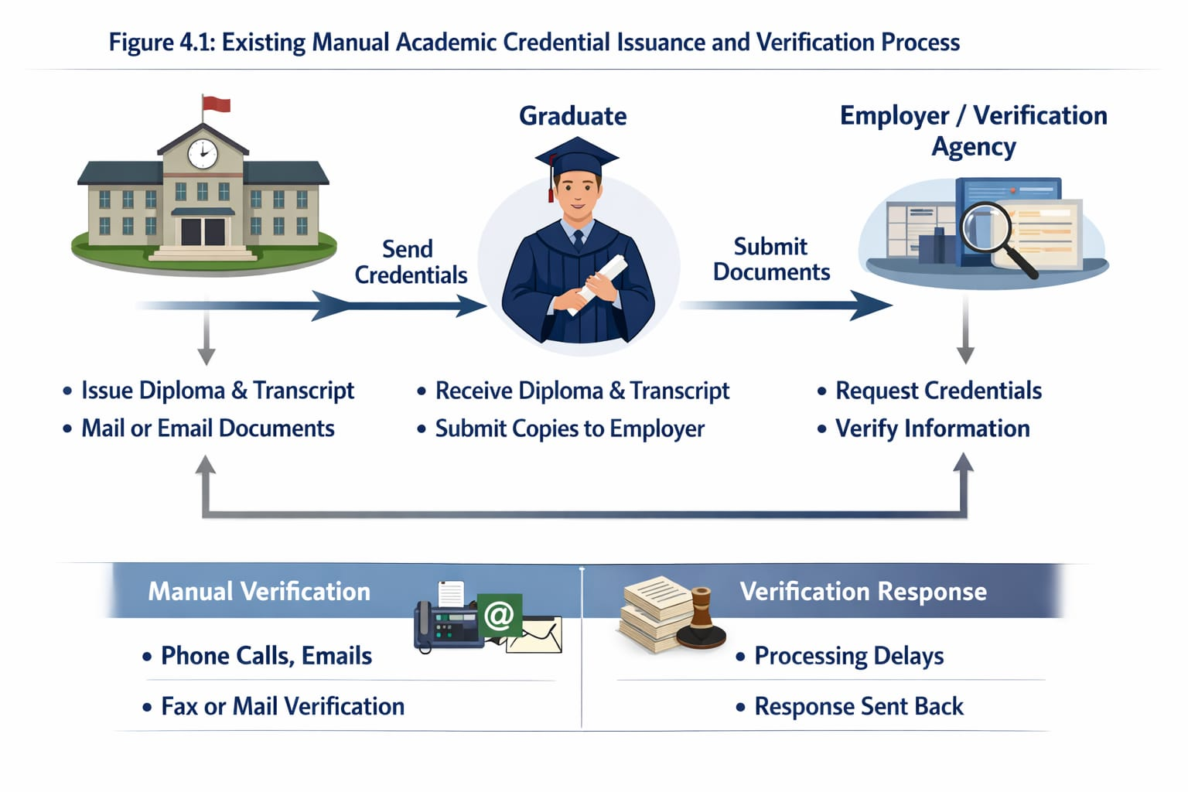

CHAPTER FIVE

SYSTEM DESIGN

5.0 Overview
This chapter presents the design of the proposed Decentralized Academic Credentials Verification system. It describes the proposed system, outlines its functional and non-functional requirements, and presents the logical and physical design of the system.

5.1 Description of the Proposed System
The proposed system is a web-based decentralized platform for issuing, managing, sharing, and verifying academic credentials. It enables institutions to issue secure digital credentials, allows students to access and manage their credentials, and gives employers the ability to verify credentials quickly and reliably.
Figure 5.1: Home Page of the Proposed System
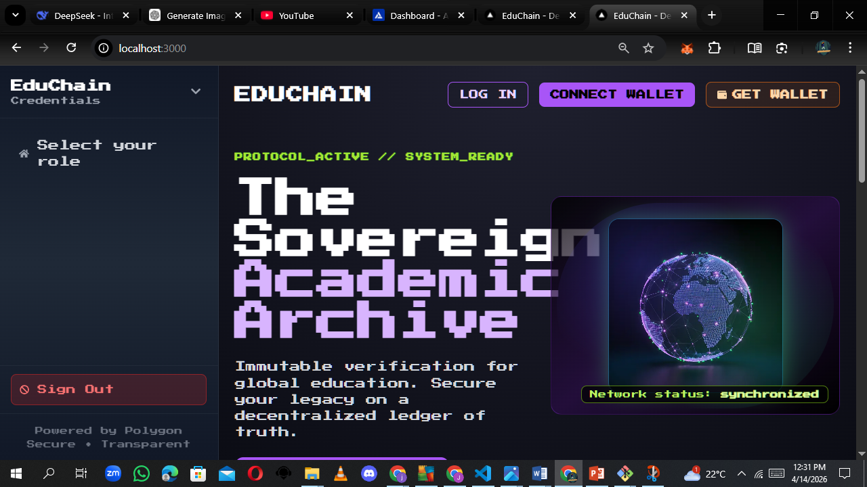

5.2 Functional Requirements of the Proposed System

5.2.1 User Authentication and Access Control
The system shall support secure login, role assignment, and restricted access based on user permissions.

5.2.2 Institution Functions
The system shall support institution onboarding, credential issuance, credential revocation, student management, and bulk import.

5.2.3 Student Functions
The system shall allow students to view, claim, share, and manage privacy settings for their credentials.

5.2.4 Employer and Verifier Functions
The system shall support single and bulk credential verification and display clear verification outcomes.

5.2.5 Administrative Functions
The system shall support approval workflows, monitoring, analytics, and audit review.

5.2.6 Interface Requirements
The interface shall validate input correctly and provide clear navigation and feedback messages.

5.2.7 Business Requirements
Required data must be provided before credential issuance and only authorized roles may perform key operations.

5.2.8 Regulatory and Compliance Requirements
The system shall maintain audit trails and restrict access to authorized users only.

5.2.9 Security Requirements
The system shall enforce role-based access control and log critical operations.
Table 5.1: Functional Requirements of the Proposed System
Requirement ID | Requirement Description | User Category | Priority
FR1 | Support user login and authentication | All users | High
FR2 | Enforce role-based access control | All users | High
FR3 | Allow institution onboarding | Institution/Admin | High
FR4 | Allow credential issuance | Institution/Admin | High
FR5 | Allow credential revocation | Institution/Admin | High
FR6 | Allow students to claim credentials | Student | High
FR7 | Allow students to share credentials | Student | High
FR8 | Allow single credential verification | Employer | High
FR9 | Support bulk verification | Employer | Medium

5.3 Non-Functional Requirements of the Proposed System

5.3.1 Performance Requirements
The system should return results quickly during normal verification and dashboard use.

5.3.2 Security Requirements
The system should protect data through authentication, authorization, and audit logging.

5.3.3 Usability Requirements
The interface should be easy to learn and use.

5.3.4 Reliability Requirements
The system should provide accurate and dependable verification results.

5.3.5 Scalability Requirements
The system should support future growth in users and records.

5.3.6 Maintainability Requirements
The system should be modular and easy to update.

5.3.7 Availability Requirements
The system should remain accessible whenever users need it.

5.3.8 Data Integrity Requirements
The system should preserve correctness and consistency of credential records.

5.3.9 Interoperability Requirements
The system should interact effectively with supporting services and platforms.
Table 5.2: Non-Functional Requirements

Requirement Type | Description | Importance Of The system
Usability | Easy to learn and use | Supports adoption
Reliability | | Accurate and dependable results | Builds trust
Scalability | Supports future growth | Long-term benefit
Maintainability | Easy to update and improve | Supports future work
Availability | Accessible when needed | Ensures continuity
Data Integrity | Correct and consistent records | Prevents misinformation
Interoperability | Works with other services | Enables integration

5.4 Logical Design of Proposed System
Logical design gives an abstract view of how the system functions. It identifies the major processes, data flows, data stores, actors, and system interactions.
Figure 5.15: Use Case Diagram for the Proposed System
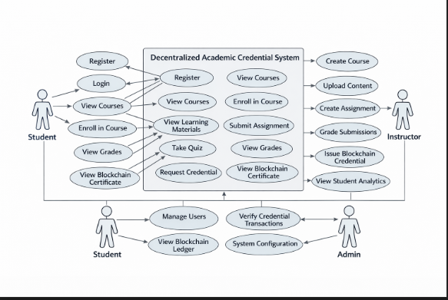
Figure 5.16: Data Flow Diagram for the Proposed System
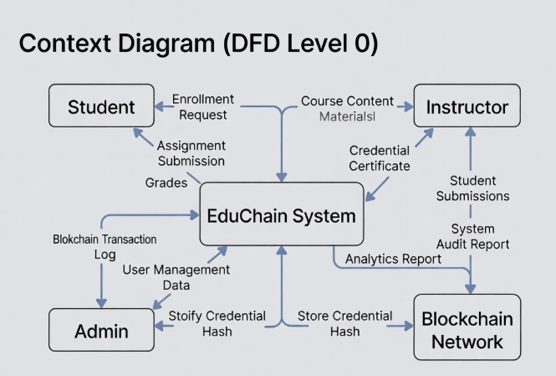

Figure 5.17: Entity Relationship Diagram
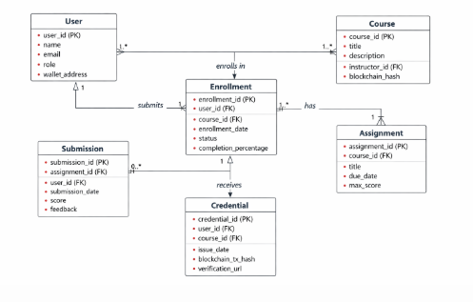

5.5 Physical Design of Proposed System

5.5.1 Input Design
Table 5.3: Input Design Specification
Input Name | Source | Format | Validated Rule
Email address | User | Text | Must be valid email format
Password | User | Text | Must meet minimum length
Issue date | Institution Admin | Date | Must be valid date
Expiry date | Institution Admin | Date | Must not be earlier than issue date
Token ID | Employer | Numeric/Text | Must exist in the system
CSV upload | Institution Admin | File | Must be valid CSV format

5.5.2 Output Design
Table 5.4: Output Design Specification
OutputName | Destination | Format | Purpose
Verification result | Employer/Verifier | Screen display | Confirms authenticity
Credential details | Student | Screen display | Shows credential information
Analytics summary | Admin | Dashboard/report | Tracks system activity
Audit log | Admin | Table/report | Table/report | Supports accountability
Bulk import result | Institution Admin | Screen/table | Shows processing outcome

5.5.3 Database Design
Figure 5.18: Physical Database Structure

5.5.5 Hardware and Software Requirements
Table 5.5: Hardware and Software Requirements
Requirement Type | Specification
Processor | Dual-core processor or higher
RAM | 4 GB minimum, 8 GB recommended
Storage | Adequate space for application files and data
Operating System | Windows, Linux, or macOS
Browser | Updated Chrome, Edge, or Firefox
Internet | Stable internet connection
Runtime Environment | Node.js
Database Support | Local or hosted database

CHAPTER SIX

SYSTEM IMPLEMENTATION

6.0 Overview
This chapter presents the implementation of the Decentralized Academic Credentials Verification system. It explains how the developed system was tested, installed, and prepared for use.

6.1 System Testing
6.1.1 Unit Testing
Unit testing was conducted on authentication, credential issuance, verification, validation, and administrative functions.
Table 6.1: Unit Testing Summary
Module | Test Case | Expected Result | Actual Result | Status
Authentication | Login with invalid credentials | User logged in | User logged in | Pass
Authentication | Login with invalid credentials | Access denied | Access denied | Pass
Credential issuance | Submit valid credential data | Credential issued | Credential issued | Pass
Credential issuance | Submit valid credential data | Validation error | Validation error | Pass
Verification | Verify valid credential | Status valid | Status valid | Pass
Verification | Verify valid credential | Status revoked | Status revoked | Pass

6.1.2 Integration Testing
Integration testing was used to confirm that the frontend, backend, database, and verification components work correctly together.
Table 6.2: Integration Testing Summary
Components Integrated | Test Scenario | Expected Result | Outcome
Frontend + Backend | Submit login request | User authenticated and dashboard opens | Successful
Frontend + Backend | Institution registration | Request saved successfully | Successful
Issuance + Processing | Issue new credential | Credential recorded and confirmation shown | Successful
Student + Sharing | Share credential | Share link/token created | Successful
Employer + Verification | Verify credential | Correct result displayed | Successful

Figure 6.1: Successful Credential Verification Result
Figure 6.2: Successful Credential Issuance or Minting Confirmation
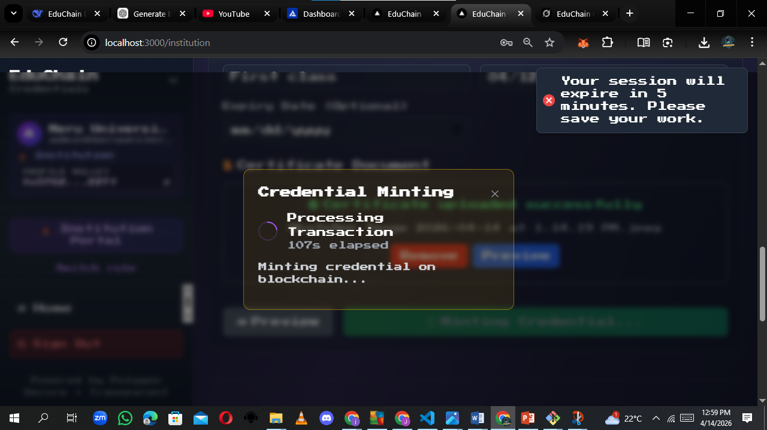

Figure 6.3: Student Credential Dashboard
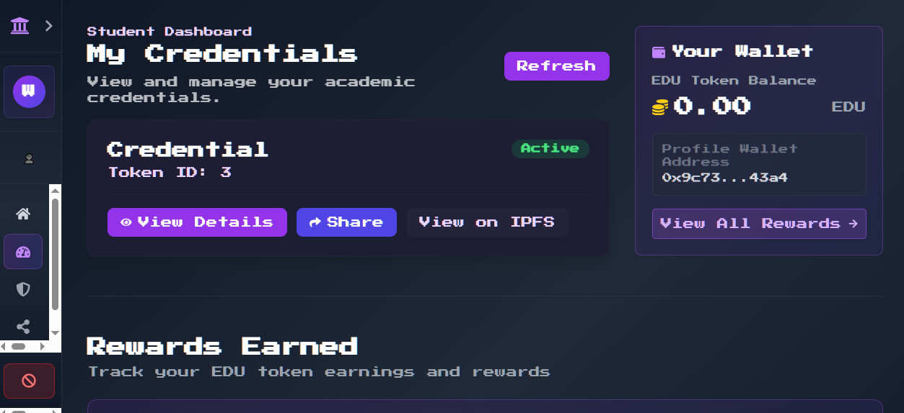

6.2 System Changeover / Installation
6.2.1 Direct Changeover
Direct changeover replaces the old system immediately and carries higher risk.
6.2.2 Parallel Changeover
Parallel changeover runs the old and new systems together for comparison.
6.2.3 Phased Changeover
Phased changeover introduces the system in modules or stages.
6.2.4 Pilot Changeover
Pilot changeover introduces the system first to a limited environment before full rollout.
6.2.5 Recommended Changeover Method
Pilot changeover supported by phased deployment is the most suitable method for this project.
6.2.6 Installation Procedure
- Install the required software tools.
- Configure the environment files required by the system.
- Set up the application database and run required migration processes.
- Configure the verification components.
- Update system configuration with the required connection details.
- Start backend services and frontend application.
- Test major workflows and train users.
Table 6.3: Installation Requirements and Procedure
Step | Activity | Expected Output
1 | Install software prerequisites | Environment ready
2 | Configure environment settings | Settings saved correctly
3 | Set up database | Database ready for use
4 | Configure verification components | Verification services available
5 | Start backend service | Backend running successfully
6 | Start frontend service | User interface accessible
7 | Test major workflows | Core features confirmed operational

6.3 Documentation
6.3.1 Internal Documentation
Internal documentation includes source code comments, system setup notes, architecture descriptions, and database schema descriptions.
6.3.2 External Documentation
External documentation includes the user manual, operation manual, installation guide, test report, and feasibility report.

CHAPTER SEVEN

CONCLUSION AND RECOMMENDATION

7.0 Achievements
The project achieved its main objective of providing a secure and efficient platform for issuing, managing, sharing, and verifying academic credentials.

7.1 Challenges
Challenges included integration complexity, data consistency, user readiness, and project resource limitations.

7.2 Proposed System Limitations
Limitations include internet dependence, user familiarity requirements, and the need for more production hardening.

7.3 Recommendation / Future Work
Future work should improve integration, scalability, usability, monitoring, and institutional deployment readiness.

7.4 Conclusion
The proposed system offers a practical and innovative approach to academic credential verification by improving trust, transparency, and efficiency.
Table 7.1: Summary of Achievements, Challenges, Limitations and Recommendations
Area | Summary
Achievements | Secure platform for issuing, managing, sharing, and verifying academic credentials
Challenges | Integration complexity, user readiness, and time constraints
Limitations | Internet dependence, adoption barriers, and production-readiness considerations
Recommendations | Improve scalability, integration, usability, and deployment readiness

APPENDICES

APPENDIX A: FEASIBILITY STUDY REPORT
A.1 Introduction
This feasibility study was conducted to determine whether the proposed Decentralized Academic Credentials Verification system is practical, sustainable, and suitable for implementation.
A.2 Purpose of the Feasibility Study
The purpose of the feasibility study is to evaluate the practicality and viability of the proposed system before its development and implementation. It aims to determine whether the required technology and resources are available to successfully build and deploy the system. Additionally, the study assesses whether the project can be completed within the available timeframe and examines the balance between expected costs and anticipated benefits. It also evaluates whether the intended users will be able to effectively operate the system with ease, and whether the system can comply with all relevant legal and institutional requirements.
A.3 Types of Feasibility Considered
Several types of feasibility were considered in this study to ensure a comprehensive evaluation of the proposed system. Technical feasibility examines whether the necessary hardware, software, and technical expertise are available. Economic feasibility evaluates the cost-effectiveness of the system by comparing the expected benefits with the implementation costs. Operational feasibility assesses how well the system will function within the existing organizational environment and whether users will be able to adopt it successfully. Legal feasibility ensures that the system adheres to all applicable laws, regulations, and institutional policies. Lastly, schedule feasibility determines whether the project can be completed within the specified timeframe.
A.4 Findings of the Study
The findings of the feasibility study indicate that the proposed system is viable and suitable for implementation. From a technical perspective, the system is achievable using the available technologies and resources. Economically, the expected benefits outweigh the costs associated with development and deployment, making the project worthwhile. Operationally, users are expected to adopt and effectively use the system, especially with adequate training and support. Furthermore, the system can be implemented in compliance with relevant legal and institutional requirements. In terms of scheduling, the project can be completed within the available timeframe, making it feasible to proceed with development.
A.5 Conclusion of the Feasibility Study
Based on the findings, the proposed system is feasible and suitable for implementation.

APPENDIX B: USER / OPERATION MANUAL
B.1 Introduction
This manual provides guidance on how to use the Decentralized Academic Credentials Verification system.
B.2 System Requirements
Users require a computer or smartphone, a modern web browser, internet connectivity, and valid credentials.
B.3 Accessing the System
Open the system URL, click the login button, enter the required credentials, and select the appropriate role where applicable.
B.4 Login Procedure
Navigate to the login page, enter your email address and password, and click the login button.
B.5 Institution Administrator Operations
Institution administrators can issue credentials, revoke credentials, and carry out bulk imports.
B.6 Student Operations
Students can view, claim, share, and manage privacy settings for their credentials.
B.7 Employer / Verifier Operations
Employers can verify a single credential or carry out bulk verification.
B.8 Administrator Operations
Administrators can approve institutions and review system logs and reports.
B.9 Troubleshooting Guide
Check credentials, network access, input correctness, and user permissions when issues occur.
B.10 Security Guidelines
Keep credentials private, log out after use, and report suspicious activity.
B.11 Conclusion
This manual provides the basic operational steps required to use the system effectively.

REFERENCES
Chen, G., Xu, B., Lu, M., & Chen, N. S. (2018). Exploring blockchain technology and its potential applications for education. Smart Learning Environments, 5(1), 1-10.

Gresch, J., Rodrigues, B., Scheid, E., Kanhere, S. S., & Stiller, B. (2021). The proposal of a blockchain-based student data management system. In 2021 IEEE International Conference on Blockchain (Blockchain) (pp. 1-8). IEEE.

Mikroyannidis, A., Domingue, J., Bachler, M., & Quick, K. (2020). A learner-centred approach to blockchain-based credentialing. IEEE Transactions on Learning Technologies, 13(4), 717-730.

Ocheja, P., Flanagan, B., & Ogata, H. (2020). Connecting decentralized learning records: A blockchain based learning analytics platform. International Journal of Learning Analytics and Artificial Intelligence for Education, 2(1), 1-16.

Sharples, M., & Domingue, J. (2016). The blockchain and kudos: A distributed system for educational record, reputation and reward. In European Conference on Technology Enhanced Learning (pp. 490-495). Springer.

Tahamtan, I., & Aslibekyan, S. (2021). Blockchain-based credentials and academic reputation system. Education and Information Technologies, 26(5), 5837-5855.

W3C. (2022). Verifiable credentials data model v1.1. https://www.w3.org/TR/vc-data-model/

